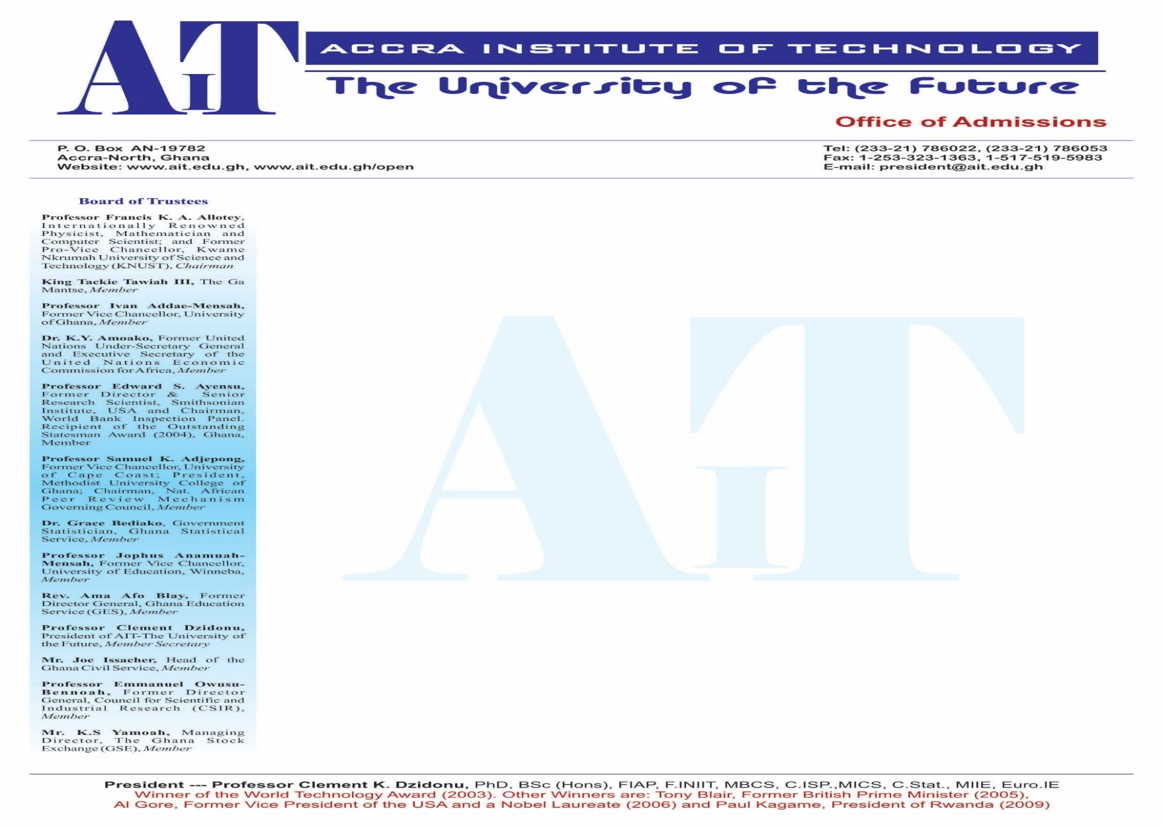

CONTINOUS ASSESSMENT SCHEDULE

**MGT403: PROJECT MANAGENT**

LECTURER NAME: ELEAZER FIANKO OFEI

INSTRUCTIONS TO CANDIDATES

**PROJECT ONE**

**Project title**: **Juice Making Factory**

**Mini Project 1**

**Project description**

You have been contacted by the One District One Factory secretariate that you have been given a concession at Dodowa to set up a juice factory in that catchment area for local and foreign export of fruit juice. The seed fund for the project is estimated at 5 million Dollars. Based on the above details you are required to plan the project using the project management knowledge areas.

**Project requirement**

The requirement of the project would be a detailed explanation of how the interchange would be constructed using the project management knowledge areas

**MINI PROJECT ONE PROJECT- (BEFORE -WEEK 7)**

1. Explain the details of your company, its setup, directors and the core expertise of the members. **[5 marks]**
2. Fully explain the project requirement in details as per the project sponsors request and what unique features you will add to the project to make it unique  **[5 marks]**
3. Explain in detail the project management life cycle suitable for such a project and justify your choice of project management lifecycle **[10 marks]**
4. The project is not expected to be without risk, what are the likely challenges you are likely to encounter and what measures would you adopt to mitigate the challenges **[10 Marks]**
5. Why would you use a scope statement in this project and what would be the contents of the scope statement? **[10 Marks]**
6. Using critical path method and network diagrams, explain how the scheduling of the project would be done. **[5 marks]**
7. How would human resources be recruited, selected, and placed on the project, further explain the as a project manager, how you would motivate employees using standard motivational processes. **[5 marks]**
8. Procurement has always been a challenge causing project cost overruns, Explain the procurement process, including sources, processes and procedures to be adopted **[10 marks]**
9. Quality procedures are necessary when it gets to projects, explain the quality assurance processes, the ISO standards to be used and the need for the standards in relation to project delivery. **[10 marks]**
10. Explain the process to be used in identifying the risk, categorizing them and indicating procedures to manage all risk. **[4 marks]**
11. Design a communication system and Explain the communication process to be adopted and relevant channels and challenges, and measures to address any communication challenges that may arise **[6 marks]**
12. Who are the stake holders for the project, explain the role of each stake holder and what stakeholder management process would be adopted to take care of stakeholder needs? **[6 marks]**
13. Explain the concluding processes to be used to ensure that the project has been formally delivered to the client. **[4 marks]**

**Presentation for Mini Project 1 and 2 [10 Marks]**

**Further requirement**

The document should be submitted in line with the following;

* Font size: 12pth
* Font: Times new roman
* Spacing: 1.5
* Alignment: Justify
* No of pages minimum: 15

**Students who fail to do a presentation of their work lose the total marks for their work.**

CONTINOUS ASSESSMENT SCHEDULE

**MGT403: PROJECT MANAGENT**

LECTURER NAME: ELEAZER FIANKO OFEI

INSTRUCTIONS TO CANDIDATES

**MAJOR PROJECT FOR SEMESTER**

**Project title**: Takoradi Market Interchange

**Project description**

The Takoradi township has petitioned the roads minister for an ultramodern inter change at the Takoradi market circle, the aim of the contract is to ease traffic within the Takoradi township. The project is a grant of 138 million dollars from the Danish grant fund from Denmark. Your company is one of the companies that has been assigned the first half of the interchanger from Effikuma to Airforce base.

**Project requirement**

The requirement of the project would be a detailed explanation of how the interchange would be constructed using the project management knowledge areas

1. Explain the details of your company, its setup, directors and the core expertise of the members. **[5 marks].**
2. Fully explain the project requirement in details as per the project sponsors request and what unique features you will add to the project to make it unique **[5 marks]**
3. Explain in detail the project management life cycle suitable for such a project and justify your choice of project management lifecycle.

**[10 marks]**

1. The project is not expected to be without risk, what are the likely challenges you are likely to encounter and what measures would you adopt to mitigate the challenges  **[10 Marks]**
2. Why would you use a scope statement in this project and what would be the contents of the scope statement? **[10 Marks]** Using critical path method and network diagrams, explain how the scheduling of the project would be done. **[10 marks]**
3. How would human resources be recruited, selected, and placed on the project, further explain the as a project manager, how you would motivate employees using standard motivational processes. **[10 marks]**
4. Procurement has always been a challenge causing project cost overruns, Explain the procurement process, including sources, processes and procedures to be adopted **[5 marks]**
5. Quality procedures are necessary when it gets to projects, explain the quality assurance processes, the ISO standards to be used and the need for the standards in relation to project delivery. **[5 marks]**
6. Explain the process to be used in identifying the risk, categorizing them and indicating procedures to manage all risk. **[5 marks]**
7. Design a communication system and Explain the communication process to be adopted and relevant channels and challenges, and measures to address any communication challenges that may arise **[5 marks]**
8. Who are the stake holders for the project, explain the role of each stake holder and what stakeholder management process would be adopted to take care of stakeholder needs?  **[5 marks]**
9. Explain the concluding processes to be used to ensure that the project has been formally delivered to the client. **[5 marks]**

**Presentation of on the project [10 marks]**

**Further requirement**

The document should be submitted in line with the following;

* Font size: 12pth
* Font: Times new roman
* Spacing: 1.5
* Alignment: Justify
* No of pages minimum: 15

**Students who fail to do a presentation of their work lose the total marks for their work.**